Roman Drill Practice:

Roman soldiers took part in drill practice as part of their daily routine. Drill practice was important as it ensured soldiers were obedient and alert, and it also bonded them with their fellow soldiers. If a soldier didn’t follow orders, they would face tough punishments!
- You can take part in drill practice to see what it would have been like as a soldier stationed on the Antonine Wall. You can take turns with one person in the role of officer and the others as soldiers. As a soldier, you may hear orders such as:

- Surgite (soor-Gee-tay) – Stand up!
- Otiose (Oh-tee-oh-say) – at this command you will stand in a relaxed manner, and you may be allowed to talk to your fellow soldiers quietly.
- Intente (In-ten-tay) -stand to attention, you must have your feet close together, your back straight, arms by your side and face forward. You must stay completely still.
- Ite Intente (Ee-tay In-ten-tay) – March to attention, in your ranks, you must march at a steady pace, in two lines. You must be quiet. If you have a sword, you must carry it in your right hand. Soldiers would carry shields in their left hand and swords in their right, so they wouldn’t cut each other with their swords when they got into tight formations
- Gladios stringite (gla-DEE-owes streen-GEE-tay) – draw swords!
- Consistite (con-cease-TEE-tay) – Halt!
- Accelera – Speed up!
- Tarda – Slow down!
- Testudo – on this command, you must hold your shield in front of you if you are positioned in front, and up over you if you’re in the back, the soldiers at the end of the line must hold their shield to the side, protecting themselves and fellow soldiers. This formation got its name as your shields would form a tortoise shell shape, providing a defence from attack. You can make your own shield out of a large piece cardboard and decorate it using coloured pens and pencils!

The soldiers were expected to memorise all these commands, and many more! How well do you think you’d get on as a soldier stationed on the Antonine Wall?

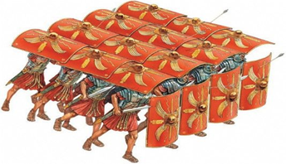(Roman soldiers forming the Testudo formation.)

